I. Introduction
This paper investigates Multidrug Resistance Among E.coli using annual percentage data from 2011 to 2024 in the US. To aim for completedness, we will cover descriptive analytics, using an assortment of tools to determine possible models and picking out the best fitting one through thorough evaluation. The final model will allow us to understand the trend as well as forecast Multidrug Resistance, which will prove substantial for medical research and public health and safety precautions.

II. Method
The analysis starts with descriptive analysis using summary statistics and graphical methods such as line plots, lag scatter plots, histograms and Q-Q plots. After concluding main features of data structure, appropriate transformations will be taken to prepare the data for model proposal by limiting skewedness, fluctuating variance and stablizing stationarity. Then, using model specification tools comprising of ACF, PACF, ADF, EACF and a BIC table, we will suggest possible ARIMA models, which then we will fit to the series. The various models will be evaluated using goodness-of-fit metrics to deliver the final optimal model for Multidrug Resistance Among E.coli.

III. Results and discussion
- Descriptive analysis
Min | 1st Qu. | Median | Mean | 3rd Qu. | Max
6.300 | 8.375 | 9.300 | 9.079 | 9.675 | 11.500
Table 1. Summary statistics of Multidrug Resistance time series.
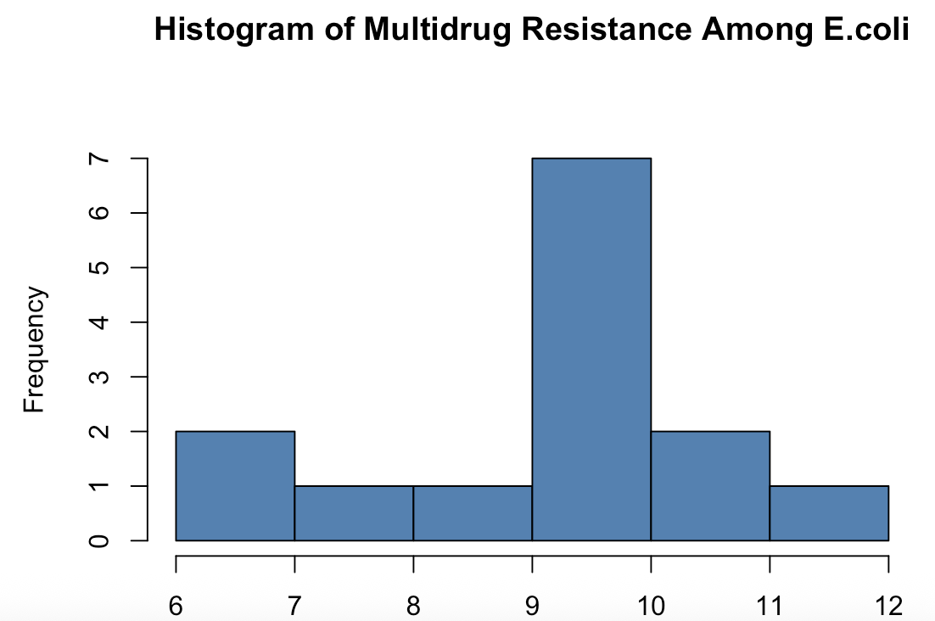
Figure 1. Histogram of Multidrug Resistance Among E.coli.

Referencing Table. 1 the data is slighly left skewed as the mean (=9.079) is marginally lower than the median (=9.300). Along with the standard deviation (=1.443), it suggests that the data is tightly distributed around the centre. Correspondingly, the entire range (6.300-11.500) almost completely belongs within 2 standard deviations from the mean. This also indicates the data is not afffected by extreme values. Furthermore, a coefficient of variance of 15.9% shows somewhat low variability and overall stability. This is corroborated by Figure. 1, as the histogram shows values densely clustered around the centre and no long tails, furthermore, the minor left-skewedness can also be seen.
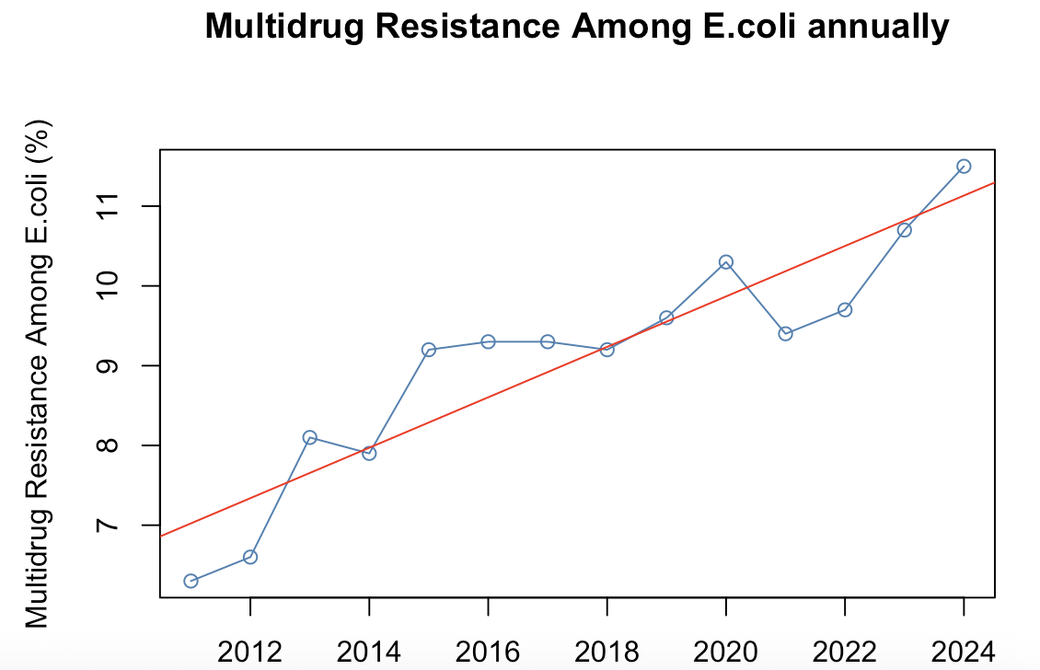
Figure 2. Line plot of Multidrug Resistance percentage annually from 2011-2024.

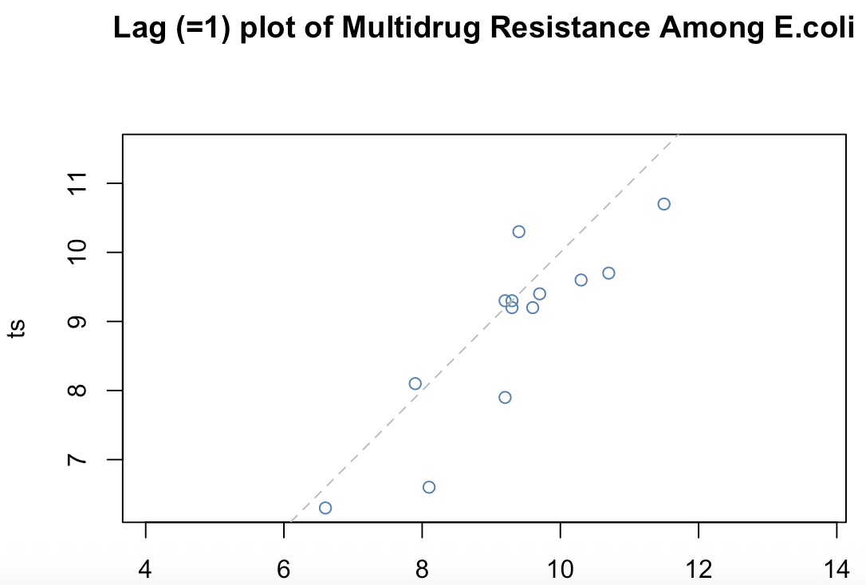
Figure 3. Lag plot of Multidrug Resistance percentage against previous year.

Figure. 2 is a plot of the data itself, in which we can very clearly see a linear upwards trend, also as represented by the red trend line. The plot also suggests autoregressive behaviour and no clear signs of changing variance or a prominent change point. The lag plot, Figure. 3, corroborates by showing a strong positive correlation between resistance levels on year t with year t-1, which can be seen through points clustering tightly along the diagonal line. This confirms the series’ autoregressive behaviour.
- Data transformations
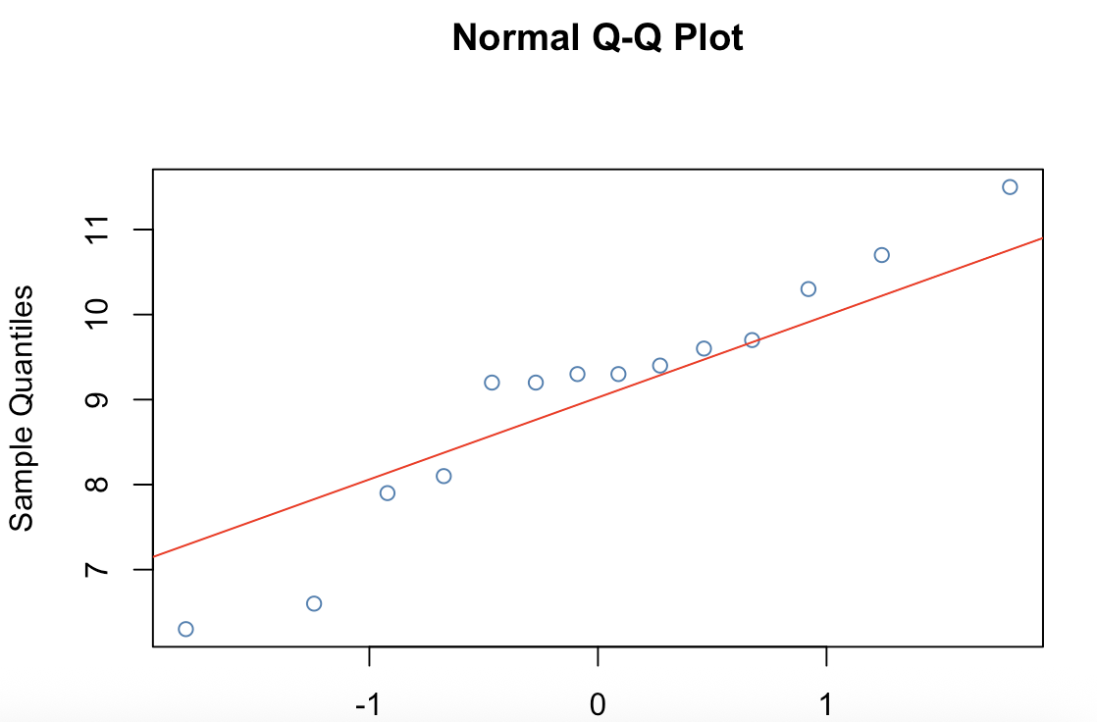
Figure 4. Q-Q plot of Multidrug Resistance Among E.coli raw series.

The Q-Q plot in Figure 4. does not conclusively show whether the series is normal or not. This is because the nature of the series having so few observations considerably limits the effectiveness of the plot.

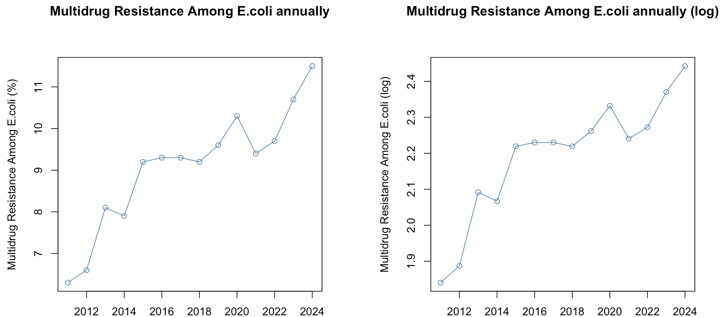
Figure 5. Comparison between raw and log plot of Multidrug Resistance Among E.coli.
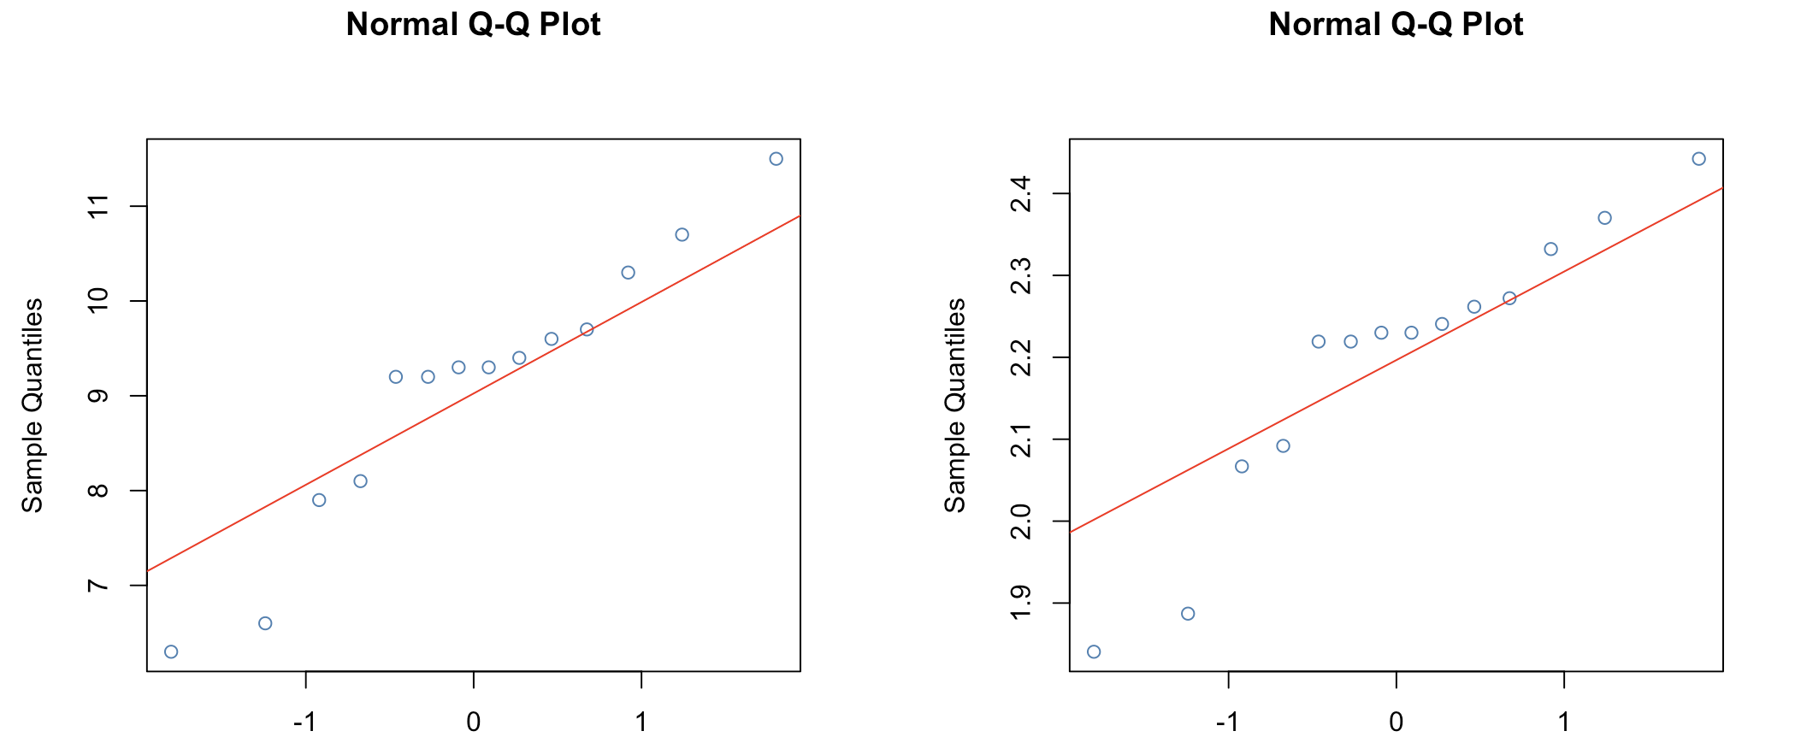
Figure 6. Comparison of raw series Q-Q plot (left) and log series Q-Q plot (right).

We continue to test by applying a log transformation to see if conditions of normality improve. A line plot in Figure 5. and Q-Q plot in Figure 6. is of the log series produced and compared with the raw series to check for improvements. While there is nearly no change, it seems the log transformation even faintly pushed points away from the Q-Q line. As a result, the log transformation proves unnecesary.

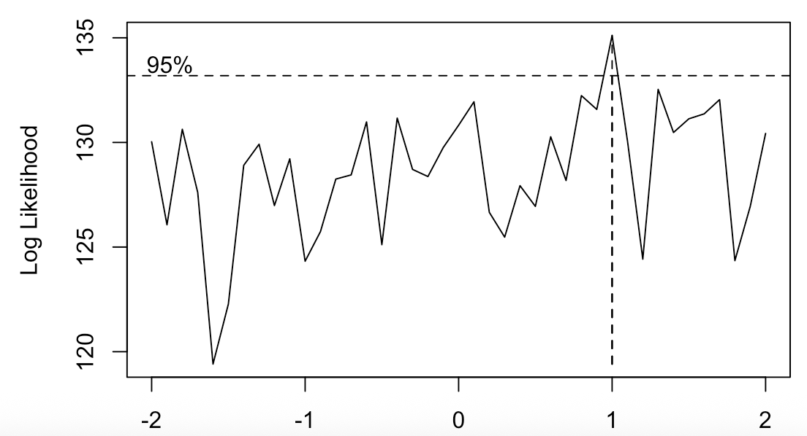
Figure 7. Boxcox plot of Multidrug Resistance Among E.coli.
After the rejection of the log transformation, a boxcox plot is generated for the series. Figure 7. demonstrates that the best lambda value equals 1. In other words, the best transformation is no transformation and that the normality of the series is adequate for use.

- Model proposals

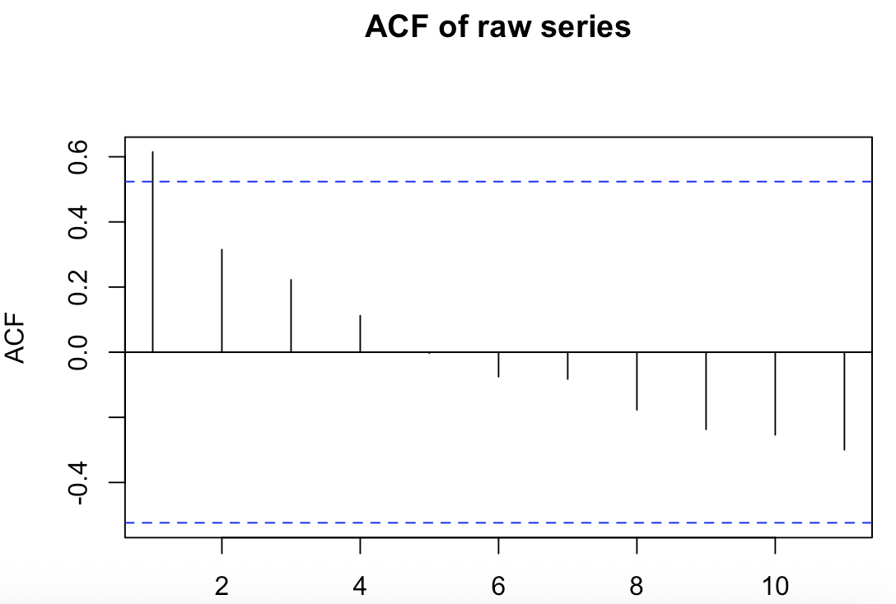
Figure 8. ACF plot of raw series Multidrug Resistance Among E.coli.
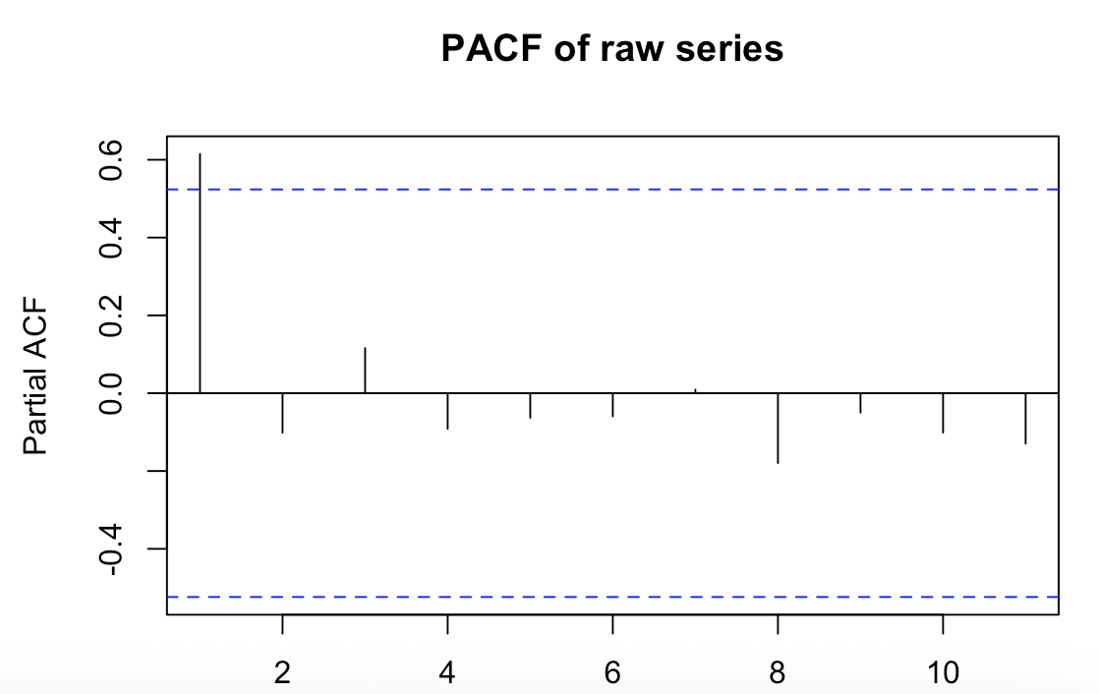
Figure 9. PACF plot of raw series Multidrug Resistance Among E.coli.

Test | P-value | Significance at 5%
ADF | 0.6412 | No
PP | 0.4247 | No
KPSS | 0.0279 | No
Table 2. Summary table with p-values of corresponding stationarity tests of raw series.

In agreement with previous findings regarding trend and autoregressive behaviour, the ACF shows a gradual decrease and PACF plot with a clear cut-off after 1. This implies that the series still needs to be diffrentiated to eliminate trend and establish stationarity. To further strengthen this point, all 3 tests, ADF, PP and KPSS suggests non-stationarity.

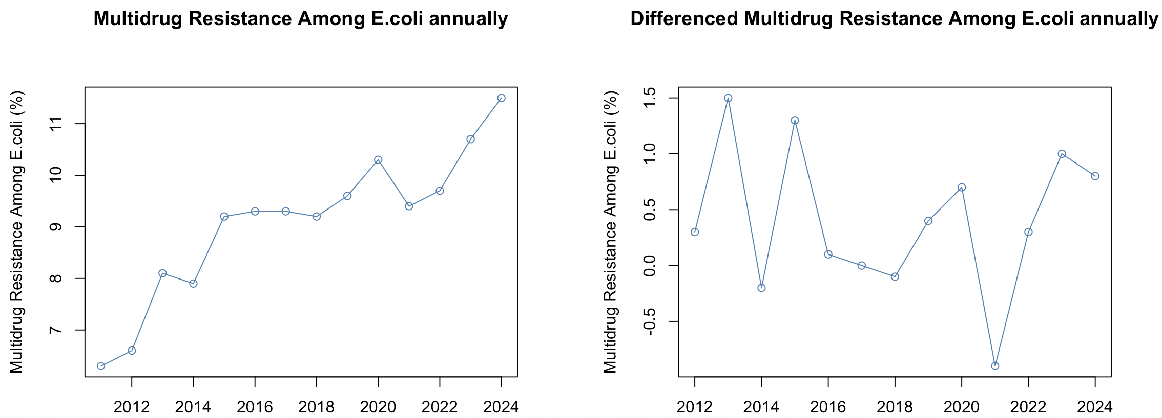
Figure 10. Comparison between raw series and differenced (=1) series Multidrug Resistance Among E.coli.

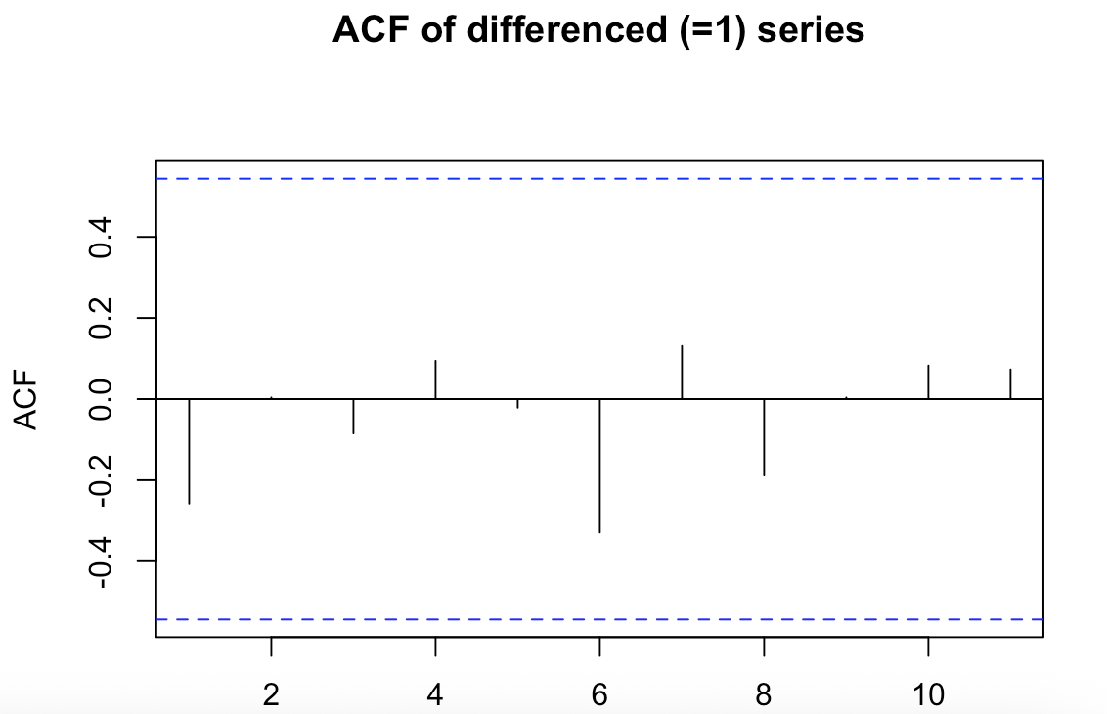
Figure 11. ACF plot of first differenced series Multidrug Resistance Among E.coli.
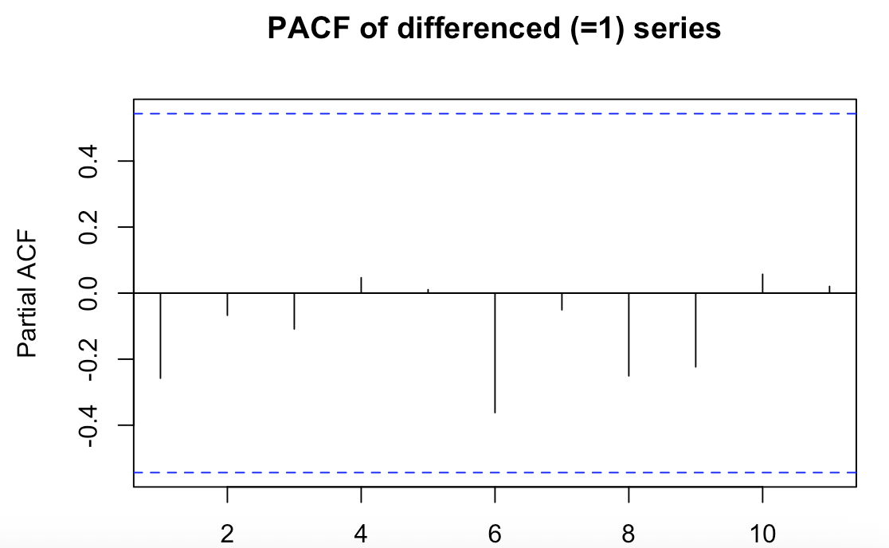
Figure 12. PACF plot of first differenced series Multidrug Resistance Among E.coli.

Test | P-value | Significance at 5%
ADF | 0.8076 | No
PP | 0.0232 | Yes
KPSS | 0.1 | Yes
Table 3. Summary table with p-values of corresponding stationarity tests of first differenced series.

As seen in Figure 10. differencing the series made a considerable difference in removing the trend. The new data now appears somewhat stationary based on the initial time series plot. The ACF and PACF shows no trend or autocorrelation, however, also indicates that there are no significant lags. The summary presented in Table 3. concludes the series as stationary in coordination with other plots as 2 out of the 3 tests confirms results by rejecting the null hypothesis of non-stationarity. The series will not be differenced further in order to avoid over-differencing, which can produce artificial results. With this information, the ACF and PACF proposes ARIMA (0,1,0), which will not be included in the final selection as it is simply a random walk model with no AR or MA behaviour.

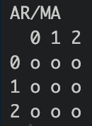
Figure 13. EACF of first differenced series of Multidrug Resistance Among E.coli.
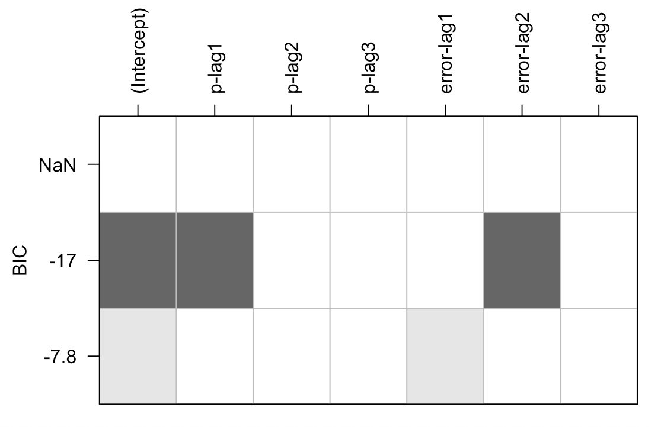
Figure 14. BIC table of first differenced series of Multidrug Resistance Among E.coli.

Moving on to other tools. The EACF in Figure 13. again proposes that there are no AR or MA behaviour, thus, is disregarded. Finally, the BIC table in Figure 14. brings forth two possible models, the strongest suggestion is ARIMA (1,1,2) and second in line suggestion is ARIMA (0,1,1). Consequently, this concludes our list with 2 possible models for this time series.
- Model fitting and evaluation

ARIMA (1,1,2) - ML |  | Estimate | Std. Error | Z-Value | P-value
 | Ma1 | 0.999574 | 0.00522 | 191.482 | <2.2e-16
 | Ma1 | -1.189774 | 0.32830 | -3.6240 | 0.00029
 | Ma2 | 0.206307 | 0.30695 | 0.6721 | 0.50151
ARIMA (1,1,2) - CSS | Ar1 | 1.405662 | 0.00394 | 356.95 | <2.2e-16
 | Ma1 | -1.976866 | 0.01870 | -105.74 | <2.2e-16
 | Ma2 | 0.264983 | 0.02282 | 11.61 | <2.2e-16
ARIMA (0,1,1) - ML | Ma1 | 0.05037 | 0.24580 | 0.2049 | 0.8376
ARIMA (0,1,1) - CSS | Ma1 | 0.05343 | 0.25363 | 0.2107 | 0.8332
ARIMA (0,1,1) – CSS-ML | Ma1 | 0.05037 | 0.24580 | 0.2049 | 0.8376
Table 4. Coefficient test summary for all models and methods with first differenced series of Multidrug Resistance Among E.coli (top suggestion highlighted).

 | df | AIC
ARIMA (1,1,2) | 4 | 35.13435
ARIMA (0,1,1) | 2 | 33.31319
Table 5. AIC summary table for all possible models with first differenced series of Multidrug Resistance Among E.coli (top suggestion highlighted).

 | df | BIC
ARIMA (1,1,2) | 4 | 37.39415
ARIMA (0,1,1) | 2 | 34.44309
Table 6. BIC summary table for all possible models with first differenced series of Multidrug Resistance Among E.coli (top suggestion highlighted).

Based on summary in Table 4. ARIMA (1,1,2) outperforms ARIMA (0,1,1) heavily, especially when using the CSS method, judging by the relative p-values suggesting that ARIMA (1,1,2) parameters estimation is very statistically significant. However, ARIMA (0,1,1) parameters are statistically insignificant regardless of the method used. On the other hand, the AIC and BIC table indicates ARIMA (0,1,1) as being the superior model with a lower score for both metrics. Not only is there a disagreement between AIC and BIC vs coefficient tests, there is also differences between ML and CSS method of model fitting, particularly for ARIMA (1,1,2). Therefore, we need to investigate additional evaluation metrics.

 | ME | RMSE | MAE | MPE | MAPE | MASE | ACF1
ARIMA (1,1,2) | 0.08123 | 0.61761 | 0.49312 | 0.89115 | 5.38551 | 0.84350 | -0.02286
ARIMA (0,1,1) | 0.35661 | 0.71989 | 0.54385 | 3.79992 | 5.87441 | 0.93027 | -0.28519
Table 7. Error metrics summary table for all possible models with first differenced series of Multidrug Resistance Among E.coli (top suggestion highlighted).

All error metrics shown in Table 7. propose that ARIMA (1,1,2) is the stronger model with lower errors across all calculation methods. Given that ARIMA (1,1,2) shows both lower predictive errors and statistically significant parameter estimates, it will be chosen as the final optimal model. Even though ARIMA (1,1,2) yield slightly lower AIC and BIC scores, this is understandable because these metrics penalize overfitting, in which this model receives a higher penalty for its higher complexity.

IV. Conclusion
Following careful inspection of the data, we found that it did not need any transformations as it did not have issues with normality or changing variance. However, it did require differentiation to remove a strong linear upwards trend. Using stationary tests, it was decided to stop at differentiation to the first degree to avoid over differentiation as 2 out of the 3 tests used, PP and KPSS rejected the null hypothesis of non-stationary. Upon using model specification tools on differenced stationary data, we were able to propose 2 most likely models for the series, ARIMA (1,1,2) and ARIMA (0,1,1). Evaluations of models after fitting showed some contradictions that required careful consideration. ARIMA (0,1,1) had the lower AIC and BIC metrics demonstrating better parsimony due to its simplicity. However, ARIMA (1,1,2) had parameters that proved to be statistically significant through the CSS method as well as conclusively lower errors across different types of error measurements. The final decision is a trade-off between simplicity and precision. ARIMA (1,1,2) was chosen to be the final optimal model, we believe that the improvement in accuracy outweighs the potential drawbacks caused by higher complexity.

V. Apendices
R code used is pasted as follows:
#importing required libraries
library("TSA")
library("tseries")
library("stats")
library("lmtest")
library("forecast")

#setting working directory and reading data
wd = setwd("~/Downloads")
df = read.csv("assignment2Data2026.csv")

#transformation into time series object
ts = ts(df$Multidrug.resistance.Among.E..coli, start = 2011, frequency = 1)

#summary stats
summary(ts)
stdev = sqrt(var(ts))
cv = sqrt(var(ts))/mean(ts)

#plots of raw data
raw_plot = plot(ts,
ylab = "Multidrug Resistance Among E.coli (%)",
main = "Multidrug Resistance Among E.coli annually",
type = "o",
col = "Steel Blue")
abline(lm(df$Multidrug.resistance.Among.E..coli~df$Year), col = "Red")

hist(ts,
main = "Histogram of Multidrug Resistance Among E.coli",
col = "Steel Blue")

lag.plot(ts, lags = 1, do.lines = FALSE,
col = "Steel Blue",
main = "Lag (=1) plot of Multidrug Resistance Among E.coli",
)

#check normality
qqnorm(ts, col = "Steel Blue")
qqline(ts, col = "Red")

#applying log transformation
ts_log = log(ts)
log_plot = plot(ts_log,
ylab = "Multidrug Resistance Among E.coli (log)",
main = "Multidrug Resistance Among E.coli annually (log)",
type = "o",
col = "Steel Blue")

qqnorm(ts_log, col = "Steel Blue")
qqline(ts_log, col = "Red")

#applying box cox transformation
bc = BoxCox.ar(ts)
bc
bc$ci
#no transformation needed because value = 1

#searching for possible models with raw data
acf(ts, main= "ACF of raw series")
pacf(ts, main= "PACF of raw series")
tseries::adf.test(ts)
PP.test(ts)
tseries::kpss.test(ts)

#searching for possible models with difference = 1
ts_diff = diff(ts)

plot(ts_diff,
ylab = "Multidrug Resistance Among E.coli (%)",
main = "Differenced Multidrug Resistance Among E.coli annually",
type = "o",
col = "Steel Blue")

acf(ts_diff, main= "ACF of differenced (=1) series")
pacf(ts_diff, main= "PACF of differenced (=1) series")
tseries::adf.test(ts_diff)
PP.test(ts_diff)
tseries::kpss.test(ts_diff)
eacf(ts_diff, ar.max = 2, ma.max = 2)
res1 = armasubsets(y=ts_diff , nar=3 , nma=3, y.name='p',
ar.method='ols')
plot(res1)

#searching for possible models with difference = 2
ts_diff2 = diff(ts, differences = 2)

plot(ts_diff2,
ylab = "Multidrug Resistance Among E.coli (%)",
main = "Differenced (=2) Multidrug Resistance Among E.coli annually",
type = "o")

acf(ts_diff2)
pacf(ts_diff2)
tseries::adf.test(ts_diff2)
PP.test(ts_diff2)
tseries::kpss.test(ts_diff2)
eacf(ts_diff2, ar.max = 2, ma.max = 2)
res2 = armasubsets(y=ts_diff2 , nar=3 , nma=3, y.name='p',
ar.method='ols')
plot(res2)

#fitting and evaluating models
model.112_ML = arima(ts, order = c(1,1,2), method = "ML")
coeftest(model.112_ML)
model.112_CSS = arima(ts, order = c(1,1,2), method = "CSS")
coeftest(model.112_CSS)

model.011_ML = arima(ts, order = c(0,1,1), method = "ML")
coeftest(model.011_ML)
model.011_CSS = arima(ts, order = c(0,1,1), method = "CSS")
coeftest(model.011_CSS)
model.011_CSSML = arima(ts, order = c(0,1,1), method = "CSS-ML")
coeftest(model.011_CSSML)

AIC(model.112_ML, model.011_ML)
BIC(model.112_ML, model.011_ML)

model.112_A = Arima(ts, order = c(1,1,2), method = "ML")
model.011_A = Arima(ts, order = c(0,1,1), method = "ML")
smodel.112 = accuracy(model.112_A)[1:7]
smodel.011 = accuracy(model.011_A)[1:7]
df.smodels = rbind(smodel.112, smodel.011)
colnames(df.smodels) = c("ME", "RMSE", "MAE", "MPE", "MAPE",
"MASE", "ACF1")
rownames(df.smodels) = c("1,1,2", "0,1,1")
df.smodels

